** Jasper County High School**

**Mr. Buddy Cain, Principal**

**14477 Hwy. 11 North**

**Monticello, GA 31064**

**“It is a great day to be a Hurricane!”**

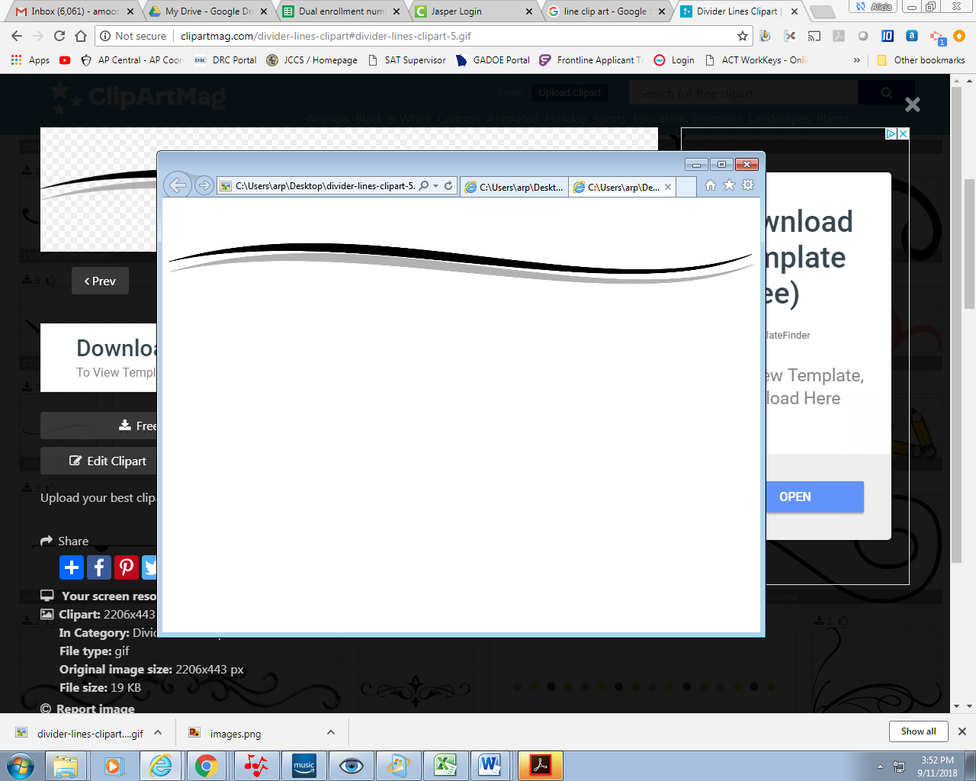

2020-2021 School Year

Welcome to Jasper County High School, “Home of the Hurricanes”. As we begin our school year and navigate the challenging waters of 2020-2021, I would like to highlight some extraordinary components to our system. We are very proud of our 2019-2020 graduation rate of %94.58 which is the highest ever officially recorded in our system. The entire community, especially our schools Pre-K to 12th grade, can be proud to be a part of this accomplishment. Also we have a sense of pride for our brand new Hurricane Stadium and athletic complex that is a tremendous addition to our school and community. I would like to thank our Board of Education who had the vision to make this tremendous complex come to reality. I’ve been around many high school athletic sites, and this is one of the finest. It is something our students already have great pride. We look forward to hosting a variety of events.

We have assembled a great faculty and staff who truly care about your children and have their best interest at heart. We are very fortunate to have a highly qualified teachers who work hard to make sure every child has the opportunity for success. Our rich network of parent and community support along with our local Board of Education, combine to make Jasper County one of the premier places to live, work, and learn. Join us to provide great opportunities for our young people as they continue to become lifelong learners.

“**It is a great day to be a Hurricane!”**

Buddy Cain

Principal

Jasper County High School